User Guide
Atlas Creation Tool
Command-line Tool User Guide

Introduction to
The Atlas Creation Tool
The Atlas Creation Tool is a command-line tool that accepts a collection of arbitrary textures and packs them into one or more texture atlases. At the end of packing it generates a human-readable texture-atlas index (.tai) file that describes how each original texture maps to an atlas (for example, which atlas file contains the original texture and which sub-rectangle of that atlas it occupies). The .tai file thus allows transforming the original texture-coordinates to texture-coordinates that access the identical data from an atlas.
To compare the output of the Atlas Creation Tool—the generated atlases—to the original texture data, one can run the Atlas Comparison Viewer (see Atlas Comparison Viewer User’s Guide: ../../AtlasComparisonViewer/Docs/).
Using texture atlases instead of individual textures helps in reducing state-changes (SetTexture() in particular), and thus in reducing number of Draw() calls per frame. Reducing state-change and Draw() calls per frame ultimately reduces CPU-utilization caused by driver overhead. The ShaderX³ chapter Improved Batching Via Texture Atlases (also available as the NVIDIA white paper Improved Batching Via Texture Atlases) discusses the theory, benefits, and limitations of texture atlases in more detail.

How to Use the Atlas Creation Tool
The Texture Atlas Tool has the following command-line invocation syntax:
TextureAtlasTool.exe [-h –help -? -nomipmap –volume
-halftexel –width <w> –height <h> –depth <d> -o <filename>]
<img1> <img2> ...
-h prints this usage help
-help prints this usage help
-? prints this usage help
-nomipmap only writes out the top-level mipmap
-volume only valid w/ -nomipmap: make atlases
volume textures
-halftexel adds a half-texel offset to the
generated texture coordinates
-width <w> limits texture atlases to a maximum width
of w texels
-height <h> limits texture atlases to a maximum
height of h texels
-depth <d> limits texture atlases to a maximum depth
of d texels
-o <filenamee> mandatory option that specifies output
filename
In other words, all parameters are optional except for the output filename and a list of two or more images to pack into an atlas. The tool supports the following file formats: .bmp, .dds, .dib, .jpg, .png, and .tga. Textures can be any size, including non-square.
Typing the following on the command-line:
TextureAtlasTool.exe –o grass.png graydirt.png
Given two images grass.png and graydirt.png of the same format generates the output shown in Figure 1. It also generates two new files: TexAtlas0.dds and TexAtlas.tai.
TexAtlas0.dds is an image file containing grass.png and graydirt.png in the Direct3D format X8R8G8B8. The TexAtlas.tai file is human-readable (see Figure 2) and describes how the texture coordinates of models using these textures need to be modified to access the same data out of the generated atlas: For example, all models using the grass.png texture before require that their u-coordinate be divided by 2 and add 0.5; to access the entire grass.png texture out of the TexAtlas0.dds the atlas texture-coordinates need to range from (0.5, 0) to
(1, 1). Similarly, all models using the graydirt.png texture require that their u-coordinate be divided by 2; to access the entire graydirt.png texture out of the TexAtlas0.dds the atlas texture-coordinates need to range from (0, 0) to (0.5, 1).

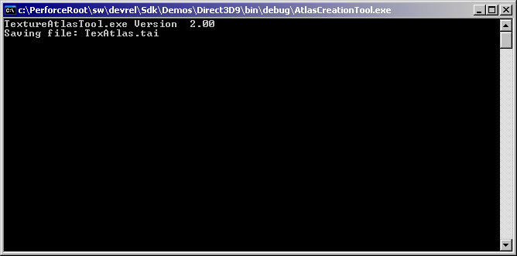
Figure 1. Command-line Output for Invoking Texture Atlas Tool with Minimal Parameters
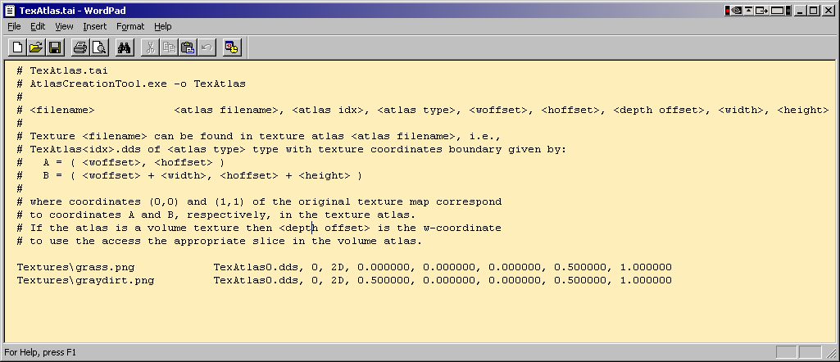
Figure 2. Generated TexAtlas.tai File

Command Line Options
-h  -help  -? | The –h command-line option prints the current usage pattern as shown:
  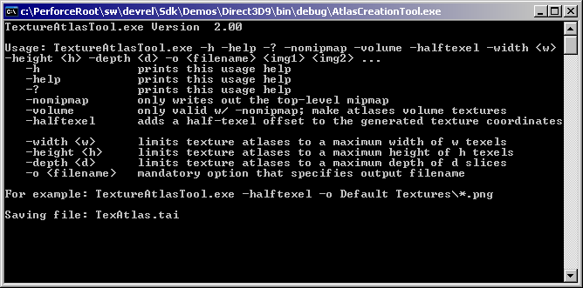
-nomipmap | The –nomipmap option instructs the application to ignore all mip-maps for all textures: All generated texture-atlases thus contain only the top-level texture, i.e., no mip-maps. This behavior is useful for user-interface or similar textures where it is guaranteed that none of the mip-map levels are ever accessed. In general, disabling mip-mapping is undesirable, as it causes prohibitive performance reductions.  In contrast, not specifying –nomipmap loads and copies all of a texture’s mip-maps into the respective atlas; if a texture does not contain any mip-maps or only a partial mip-map chain, then the Texture Atlas Tool relies on D3DXCreateTextureFromFileEx()with D3DX_DEFAULT parameters to generate the missing mip-maps. The resulting quality is thus questionable: using NVIDIA’s texture tools (http://developer.nvidia.com/object/nv_texture_tools.html) to generate all mip-maps for all textures before passing them to the Texture Tool Atlas is preferred.
-volume | The –volume option specifies that all generated atlases are to be volume textures. This option requires that  –nomipmap is also specified, since volume atlases cannot store the mipmaps of textures.
-halftexel | The –halftexel option offsets all generated texture coordinates by half a texel so as to ensure that only the texels of the original texture are accessed. See also the ShaderX³ chapter for details.
-width <w> | The –width option limits the maximum width of all generated atlases to w.
-height <h> | The –height option limits the maximum height of all generated atlases to h.
-depth <d> | The –depth option limits the maximum depth of all generated volume atlases to d.
-o <filename> | The –o option specifies the name of the generated atlas and .tai files. For example, specifying –o Test will generate atlas files of the form Test0.dds, Test1.dds, etc, and a Test.tai file.

Typical Use Case
A graphics-engine programmer identifies a collection of textures that are responsible for a large number of DrawPrimitive() calls due to repeated calls to SetTexture(). These textures ideally are of or are converted to the same format to maximize the efficiency of packing them into atlases. If some of these textures do not contain complete mip-map chains, integrate NVIDIA’s texture tools into the tool chain to generate and store these mip-maps together with the original textures. (Various file-formats, e.g., .dds, allow storing mip-map levels together with the original image.) Similarly, integrate the Atlas Creation Tool into the tool chain to convert these texture collections into collections of atlases. Create and integrate a separate tool that parses the generated .tai file to remap texture-coordinates of models to enable texturing out of the generated texture atlases.
Optionally, use the Atlas Comparison Viewer or a similar home-made tool able to display converted models to inspect the resulting image quality of texturing out of an atlas versus texturing from the original texture.

Known Bugs
Running with the DirectX 9 Summer 2003 DEBUG runtime and packing DXTn-format textures generates a Direct3D error and thus forces the application to exit. We are currently investigating the root cause for this error. Switching to the retail run-time works around that error.

Next Version Features
The following is a list of currently unimplemented features under consideration for the next version of this application.
- Add –cubemap option: only valid if at most 6 textures of the same format/dimension are supplied.
- Use the reference rasterizer as the hardware device: that way we get maximum capabilities, texture formats, and texture resolutions.
- Add a command-line option to force all generated atlases to a particular format.

Notice
ALL NVIDIA DESIGN SPECIFICATIONS, REFERENCE BOARDS, FILES, DRAWINGS, DIAGNOSTICS, LISTS, AND OTHER DOCUMENTS (TOGETHER AND SEPARATELY, “MATERIALS”) ARE BEING PROVIDED “AS IS." NVIDIA MAKES NO WARRANTIES, EXPRESSED, IMPLIED, STATUTORY, OR OTHERWISE WITH RESPECT TO THE MATERIALS, AND EXPRESSLY DISCLAIMS ALL IMPLIED WARRANTIES OF NONINFRINGEMENT, MERCHANTABILITY, AND FITNESS FOR A PARTICULAR PURPOSE.
Information furnished is believed to be accurate and reliable. However, NVIDIA Corporation assumes no responsibility for the consequences of use of such information or for any infringement of patents or other rights of third parties that may result from its use. No license is granted by implication or otherwise under any patent or patent rights of NVIDIA Corporation. Specifications mentioned in this publication are subject to change without notice. This publication supersedes and replaces all information previously supplied. NVIDIA Corporation products are not authorized for use as critical components in life support devices or systems without express written approval of NVIDIA Corporation.

Trademarks
NVIDIA and the NVIDIA logo are trademarks or registered trademarks of NVIDIA Corporation. Other company and product names may be trademarks of the respective companies with which they are associated.

Copyright
© 2004 NVIDIA Corporation. All rights reserved

